1. Purpose
This document consolidates Capital Adequacy Ratio (CAR), Liquidity Coverage Ratio (LCR), and Leverage Ratio (LR) into a single dashboard. It provides compliance and resilience flags under both baseline and stress conditions, with unified Basel III codes (1–14) for traceability.

2. Program Overview
Program | Role
main_dashboard.py | Entry point. Connects to database, fetches inputs, calculates CAR, LCR, and Leverage, applies compliance/resilience logic, and prints the consolidated table.
ratios_car.py | Functions for CAR baseline and stress calculations.
ratios_liquidity.py | Functions for LCR baseline and stress calculations.
ratios_leverage.py | Functions for Leverage baseline and stress calculations.
code_mapping.py | Shared module. Maps ratio outcomes to Basel codes (1–14).

3. Dashboard Logic
- Compliance Flag: Y if all baseline ratios meet thresholds (CAR ≥ 8%, LCR ≥ 100%, LR ≥ 3%).
- Resilience Flag:
  - Resilient → Baseline and stress both pass.
  - Fragile (Compliant Only) → Baseline passes but one or more stressed ratios fail.
  - Non-Resilient → Baseline fails outright.
- Codes: Numeric identifiers unify CAR, LCR, and LR outcomes. Extended set includes:
  - Code 10 – Stress: Market Downturn
  - Code 11 – Stress: Credit Shock
  - Code 12 – Stress: Funding Squeeze
  - Code 13 – Stress: Combined Stress
  - Code 14 – Recovery/Resolution

4. Consolidated Dashboard Table

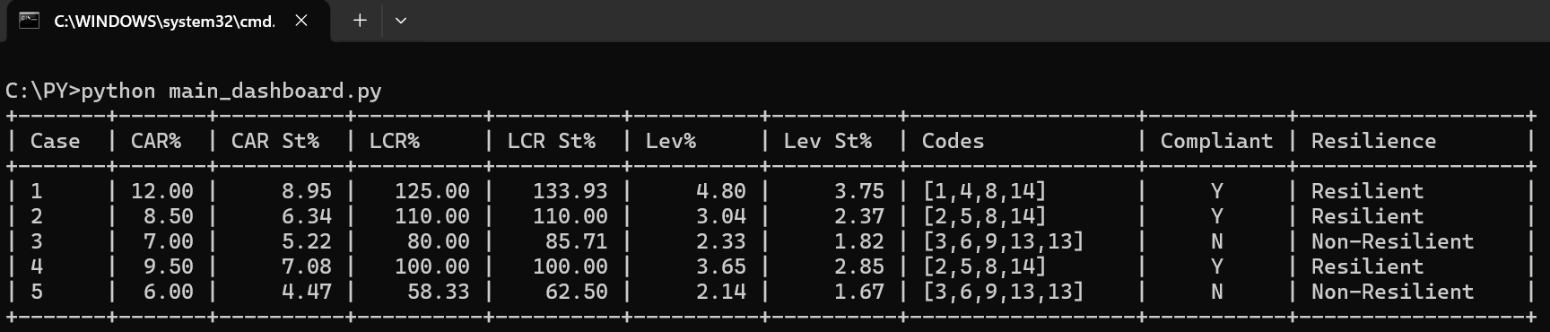
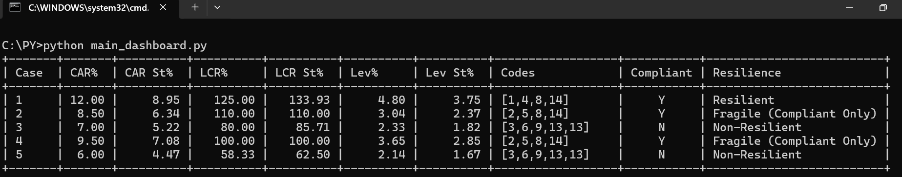

Figure 1 – Basel III Resilience Classification Flowchart This diagram illustrates the decision logic used to classify resilience outcomes:
- Resilient → Compliant with strong buffer
- Fragile (Compliant Only) → Compliant but weak buffer
- Non-Resilient → Non-compliant / below baseline
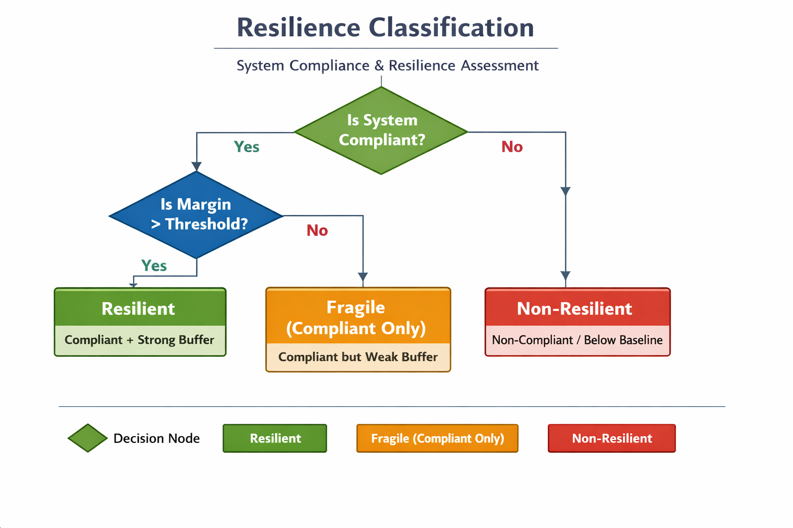

5. Executive Narrative
- Resilient Cases: Baseline and stress thresholds satisfied (e.g., Case 1).
- Fragile (Compliant Only) Cases: Baseline thresholds satisfied but stress breaches occur (e.g., Case 2, Case 4).
- Non-Resilient Cases: Fail compliance outright at baseline (e.g., Case 3, Case 5).
- Codes: Extended Basel III set applied, including stress markers — Code 10 (Market Downturn), Code 11 (Credit Shock), Code 12 (Funding Squeeze), and Code 13 (Combined Stress) — plus Code 14 (Recovery/Resolution).
- Interpretation: The dashboard highlights resilience gaps clearly, distinguishing between outright breaches and fragile compliance, with numeric codes ensuring traceability across CAR, LCR, and Leverage.

6. Conclusion
The Dashboard Summary (Basel III) is the final consolidated deliverable. It merges CAR, LCR, and Leverage into one CFO-ready table, with compliance and resilience flags plus unified Basel III codes (1–14). This ensures transparency, traceability, and executive clarity in a single document.

7. Program Detail
For other modules (ratios_car.py, ratios_liquidity.py, ratios_leverage.py, and code_mapping.py), please refer to the Capital Adequacy Guideline, Liquidity Coverage Guideline, and Leverage Guideline documents.

main_dashboard.py
# ============================
# Basel III Dashboard Program
# ============================

import psycopg2

from ratios_car import calc_car, calc_car_stress
from ratios_leverage import calc_leverage, calc_leverage_stress
from ratios_liquidity import calc_lcr, calc_lcr_stress
from code_mapping import assign_codes

# ----------------------------
# Database Connection
# ----------------------------
conn = psycopg2.connect(
host="localhost",
port="5432",
database="basel_capital",
user="postgres",
password="sa"
)

cursor = conn.cursor()

cursor.execute("""
SELECT equity, rwa, assets, hqla, outflows,
stress_equity, stress_rwa, stress_assets,
stress_outflows, stress_inflows
FROM forecast_inputs;
""")

rows = cursor.fetchall()

# ----------------------------
# Print Table Header
# ----------------------------
print("+-------+-------+----------+----------+----------+----------+----------+------------------+-----------+--------------------------+")
print("| Case | CAR% | CAR St% | LCR% | LCR St% | Lev% | Lev St% | Codes | Compliant | Resilience |")
print("+-------+-------+----------+----------+----------+----------+----------+------------------+-----------+--------------------------+")

# ----------------------------
# Process Each Case
# ----------------------------
for idx, row in enumerate(rows, start=1):
equity, rwa, assets, hqla, outflows, stress_equity, stress_rwa, stress_assets, stress_outflows, stress_inflows = row

# Baseline ratios
car = calc_car(equity, rwa)
lcr = calc_lcr(hqla, outflows, 0)
leverage = calc_leverage(equity, assets)

# Stressed ratios
car_stress = calc_car_stress(equity, rwa, stress_equity, stress_rwa)
lcr_stress = calc_lcr_stress(hqla, stress_outflows, stress_inflows)
leverage_stress = calc_leverage_stress(equity, assets, stress_equity, stress_assets)

# ✅ Compliance based on baseline ratios
compliant_flag = 'Y' if car >= 8 and lcr >= 100 and leverage >= 3 else 'N'

# Codes
codes = assign_codes(car=car, lcr_base=lcr, leverage=leverage, lcr_stress=lcr_stress)
if compliant_flag == 'N':
codes.append(13)
codes_str = "[" + ",".join(str(c) for c in codes) + "]"

# ✅ Resilience classification (three-tier logic)
if car >= 8 and lcr >= 100 and leverage >= 3:
# Baseline compliant
if car_stress >= 8 and lcr_stress >= 100 and leverage_stress >= 3:
resilience = "Resilient"
else:
resilience = "Fragile (Compliant Only)"
else:
# Baseline fails outright
resilience = "Non-Resilient"

# Print results
print("| {:<5} | {:>5.2f} | {:>8.2f} | {:>8.2f} | {:>8.2f} | {:>8.2f} | {:>8.2f} | {:<16} | {:^9} | {:<24} |".format(
idx, car, car_stress, lcr, lcr_stress, leverage, leverage_stress, codes_str, compliant_flag, resilience
))

print("+-------+-------+----------+----------+----------+----------+----------+------------------+-----------+--------------------------+")

cursor.close()
conn.close()

Appendix A – Basel III Code Mapping
Code | Program-defined Category | Description | Basel III Relevance | Threshold Criteria | Example Scenario
1 | High Capital Adequacy | Equity strong relative to RWA | Shows compliance strength | CAR ≥ 10% | Bank with surplus retained earnings
2 | Borderline Capital | Equity just above minimum | Highlights threshold risk | 8% ≤ CAR < 10% | Bank meeting minimum ratios but vulnerable
3 | Undercapitalized | Equity below RWA requirement | Breach scenario | CAR < 8% | Bank hit by credit losses
4 | Liquidity Surplus | HQLA far above outflows | Strong liquidity buffer | LCR ≥ 120% | Bank holding excess government bonds
5 | Balanced Liquidity | HQLA ≈ outflows | Neutral compliance | 100% ≤ LCR < 120% | Bank operating at liquidity threshold
6 | Liquidity Shortfall | HQLA below outflows | Breach scenario | LCR < 100% | Bank facing deposit run
7 | Conservative Leverage | Low asset/equity ratio | Safe leverage | Leverage ≥ 5% | Bank with cautious balance sheet
8 | Moderate Leverage | Balanced asset/equity | Acceptable leverage | 3% ≤ Leverage < 5% | Bank with moderate expansion
9 | Excessive Leverage | High asset/equity ratio | Risky leverage | Leverage < 3% | Bank expanding balance sheet aggressively
10 | Stress – Market Downturn | Asset values fall | CAR/LCR pressure | CAR or LCR drop ≥ 20% | Market crash reduces asset values
11 | Stress – Credit Shock | RWA spikes | CAR collapse | RWA ↑ sharply → CAR < 8% | Credit defaults increase RWA
12 | Stress – Funding Squeeze | Outflows surge | LCR breach | Outflows ↑ sharply → LCR < 100% | Wholesale funding dries up
13 | Stress – Combined | Multiple shocks | Basel III breach across ratios | CAR < 8% and LCR < 100% | Market crash + deposit run
14 | Recovery/Resolution | Equity injection or liquidity support | Post-stress compliance | Ratios restored ≥ thresholds | Bank recapitalized or supported

Appendix B – Module Cross-Reference
Module | Guideline Document | Purpose
ratios_car.py | Capital Adequacy Guideline | Calculates CAR baseline and stress ratios.
ratios_liquidity.py | Liquidity Coverage Guideline | Calculates LCR baseline and stress ratios.
ratios_leverage.py | Capital Adequacy & Leverage Guideline | Calculates Leverage baseline and stress ratios.
code_mapping.py | Ratio Automation Guideline | Maps CAR, LCR, and Leverage outcomes to Basel III codes (1–14).
main_dashboard.py | Dashboard Summary (Basel III) | Consolidates CAR, LCR, and Leverage into one CFO-ready dashboard table.

